Formatting guidelines for authors submitting initial abstract for the EARSeL 2019 Digital I Earth I Observation  (Style: Title abstract) |  | EARSeL 2019  Digital I Earth I Observation  Abstract  Corresponding Author: barbara.riedler@sbg.ac.at (Style: e-mail corresponding author)
Barbara Riedler, Second Author², Third Author³, Fourth Author⁴
(Style: Authors, presenting author underlined)
¹ University of Salzburg, Department of Geoinformatics Z_GIS, Austria
²University of XXXXXX, Country
³ University of XXXXXX, Country
⁴ University of XXXXXX, Country
(Style: Affiliations;)
Keywords: EARSeL 2019, abstract, formatting guidelines (Style: keywords)

Abstract (STYLE: Heading Abstract)
This document serves as a formatting template for authors submitting an abstract to the EARSeL 2019. It contains all the necessary style elements for you to prepare the abstract in the preferred format. This abstract will be used to assist the organizers in selecting papers for presentation and in designing the programme. The abstract should contain between 500 and 800 words and does not normally contain references. One figure shall be provided at the end of the text. As in Figure 1, it should be centered and occupying the whole space without any text on the right and left-hand sides. Graphics should have an adequate resolution. Colours can be used; however, it is recommended that the graphics are checked to reproduce the required details in the gray-scale copy. The document itself is set out using the layout and styles for the abstract. Your abstract should be saved in a file named as follows: start with the surname of the first author et al, followed by EARSeL2019, e.g. “Riedler et al EARSeL.docx”. The documents is required to be uploaded in the Conference tool to be considered for review. (Style: body text)

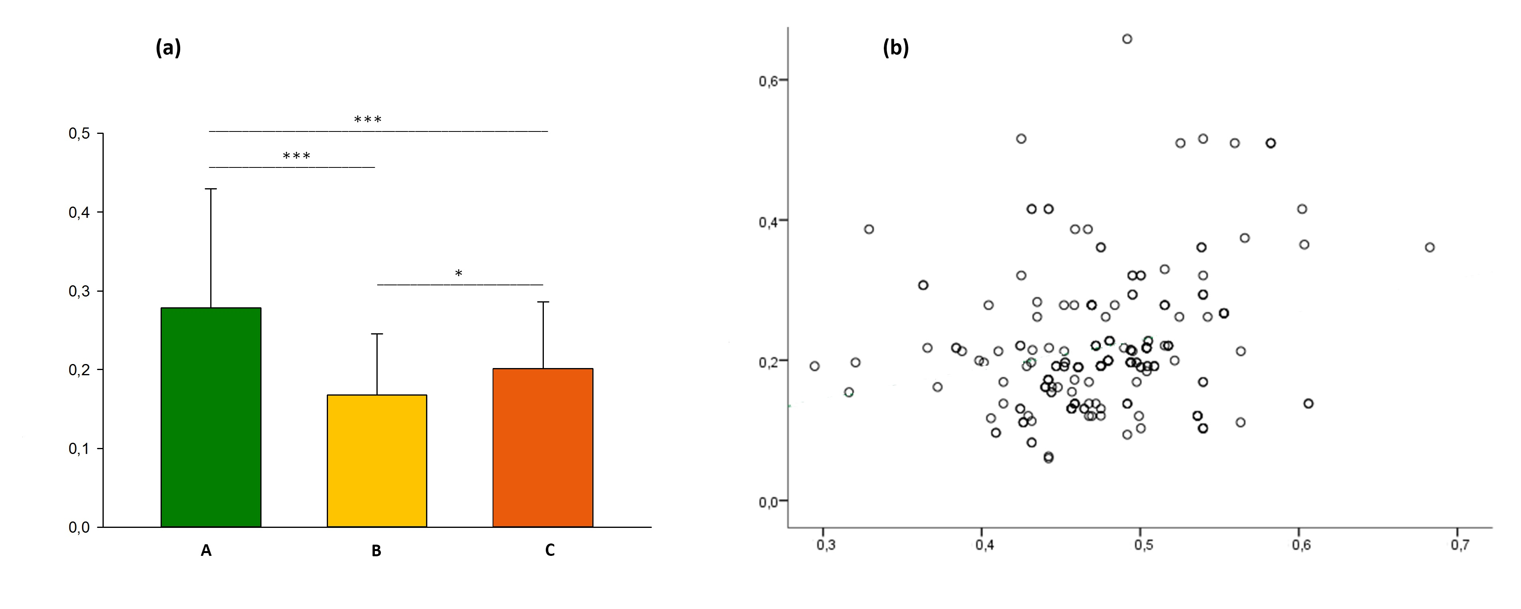
Figure 1. (a) example of coloured figure and (b) example of grey-scale figure
(Style: Figure Caption, plus tab space after Figure number)

